**I.T to aid communication**

I.T can aid communication in many ways, as it allows almost everything that can be done face-to-face, but removes the distance barrier.

**Word processing**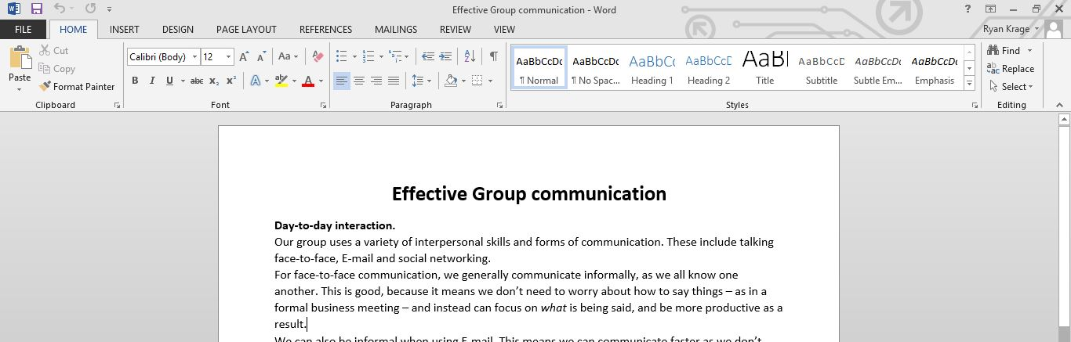

Word processing (typing a document on a computer rather than writing it by hand) greatly aids communication, as it ensures documents are easier to read (no doctors handwriting!), are better formatted (and look more professional as a result), contain fewer mistakes (as text can be deleted rather than crossed out) and perhaps most importantly, can be sent to almost any other computer in the world.  
If a person in my group is ill, or on holiday, or it’s the weekend, and cannot come in, I can email them the document I am working on so they can review it.  
Even if they are in the same room, it is useful to be able to email them it, as they can then take it anywhere on their computer and are less likely to lose it.  
It also allows much more information to be put in a document in-line, such as charts and graphs. (The data in this chart is an example only, and is not accurate).

**Presentation Software**  
Presentation software, such as PowerPoint or Pro Presenter, makes presentations and talks much more interesting, and allows multimedia, including text, images, videos and other graphics to be easily shown to large groups of people.  
It makes the presentation more interesting because it gives the audience something to look at besides the speaker, so they are less likely to become bored or distracted.  
It allows the presenter to show additional information (extra points, or charts and graphs), so the audience can get more information than the speaker has time to say.  
Additionally, it enables the presenter to easily show multimedia, which can illustrate a point far more effectively than words alone ever could.

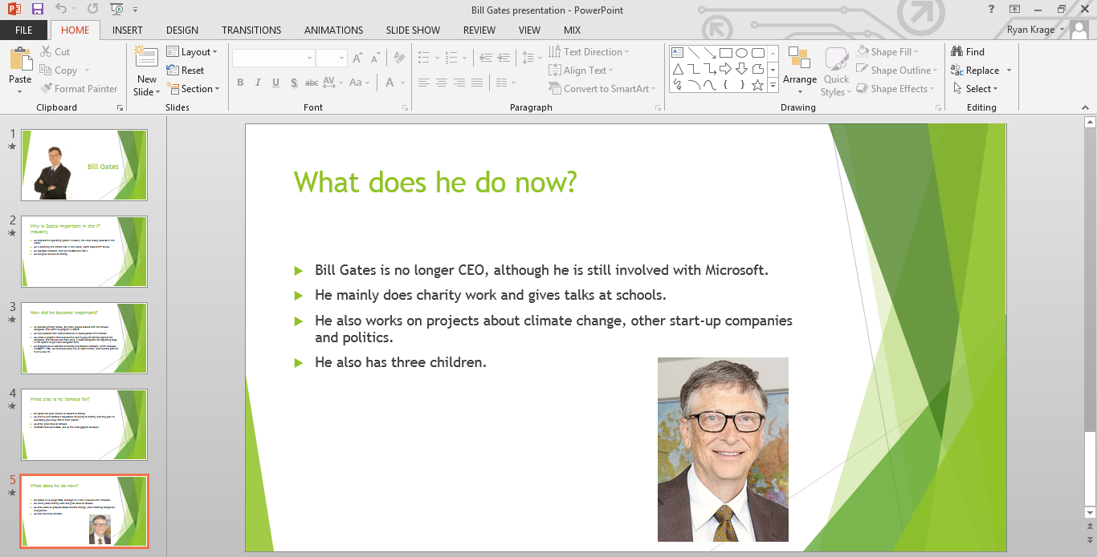  
A presentation about Bill Gates.

**E-mail**We can communicate large amounts of information over long distances and time frames with email.  
We can type out pages of information, as opposed to speaking a few sentences, and send documents, reports and multimedia files with the click of a button. It is also possible to think much more carefully about how best to respond when replying to an email, as the recipient won’t mind if a reply comes a few minutes, hours or even days (depending on the importance of the topic) later.

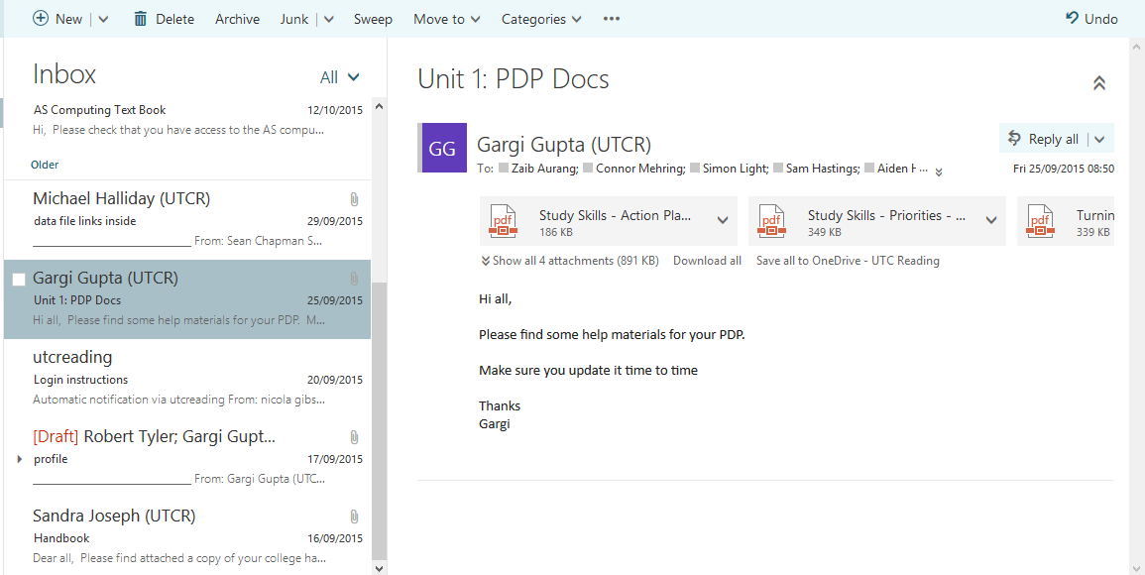  
An email with documents attached.